For Yolo v5

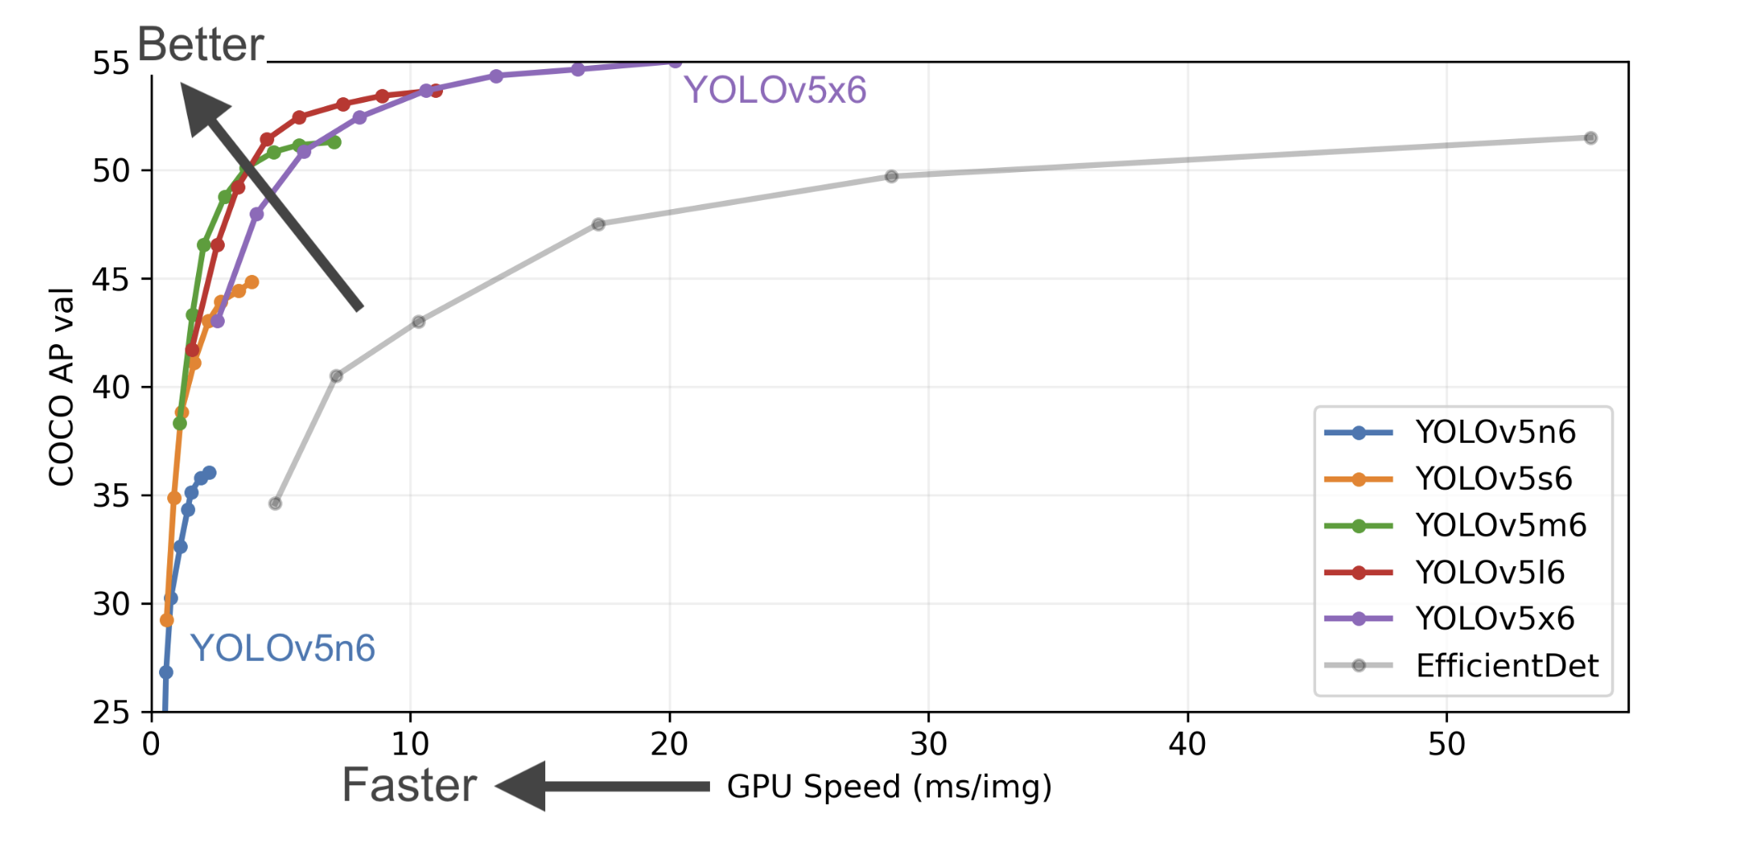

Using Yolov5x6

1. Sheffield Traffic

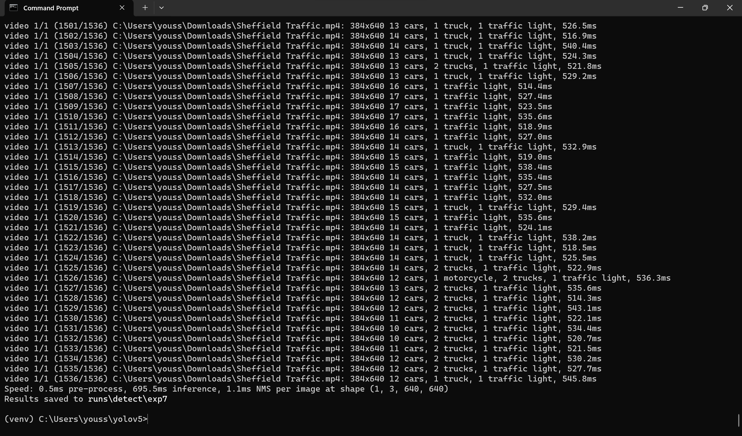

1. living-room-interior

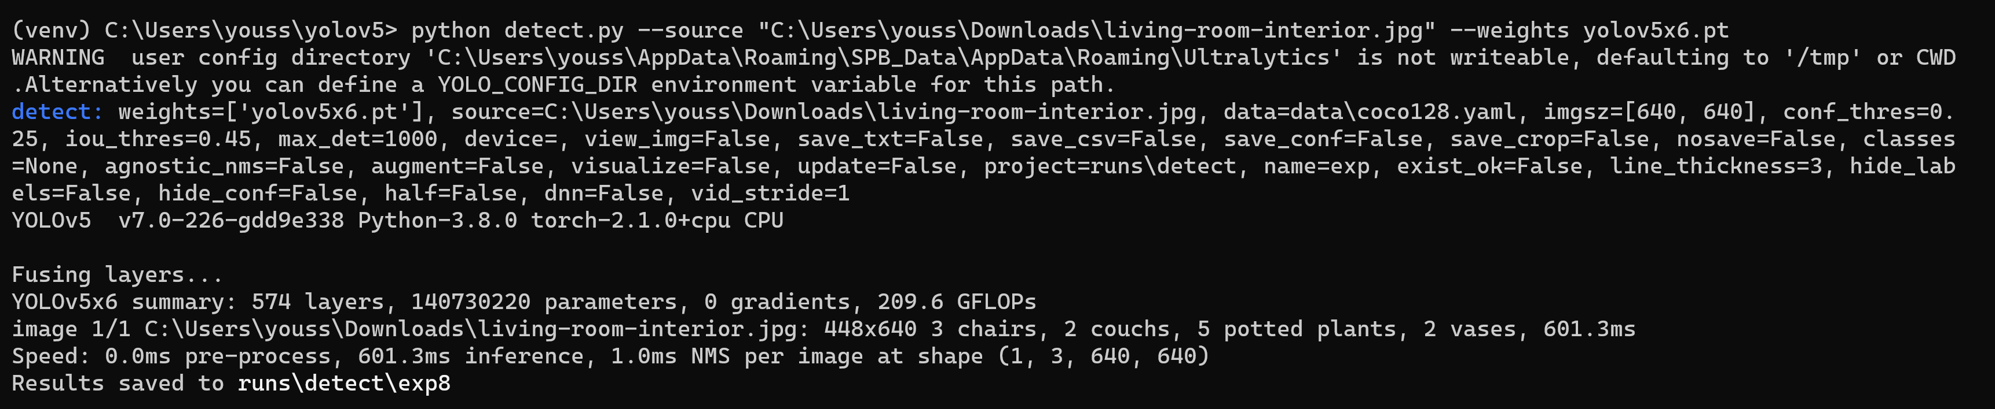

1. football-raw-clip

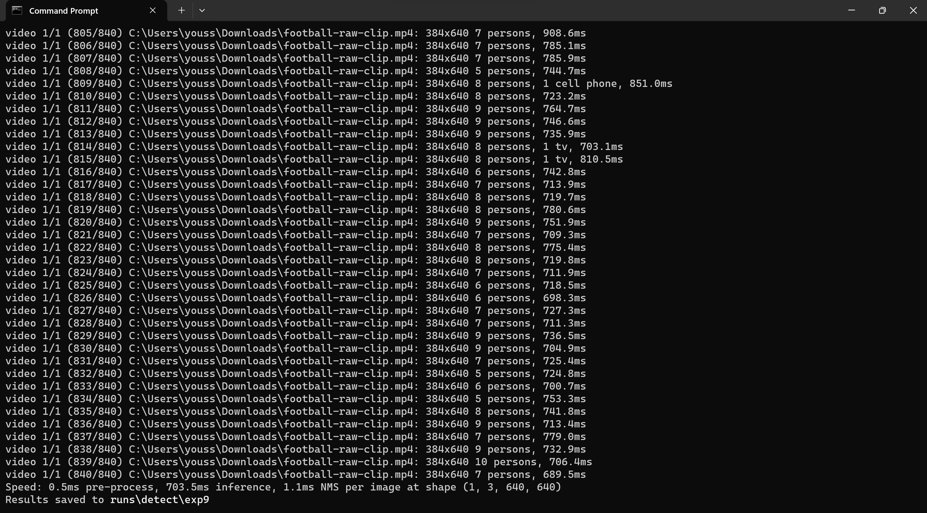

1. denver-open-streets

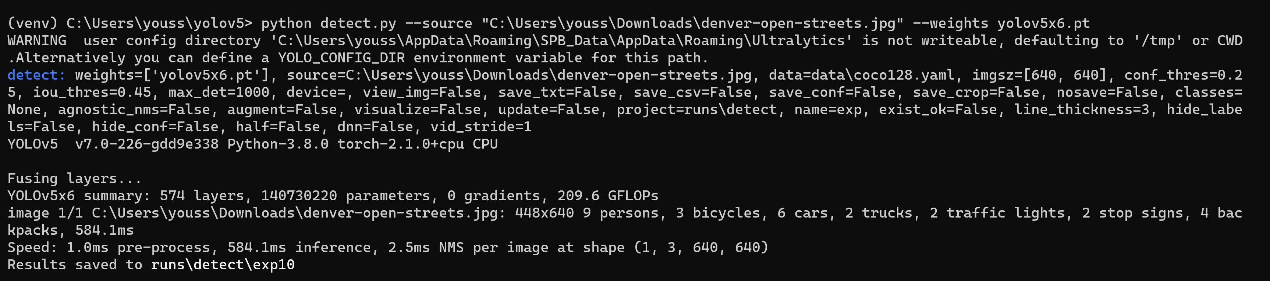

1. cats_and_dogs

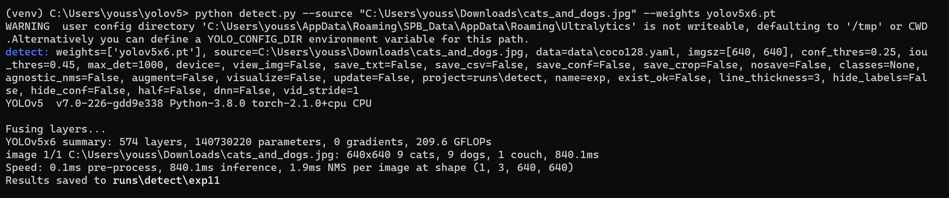

Using Yolov5n6

1. Sheffield Traffic

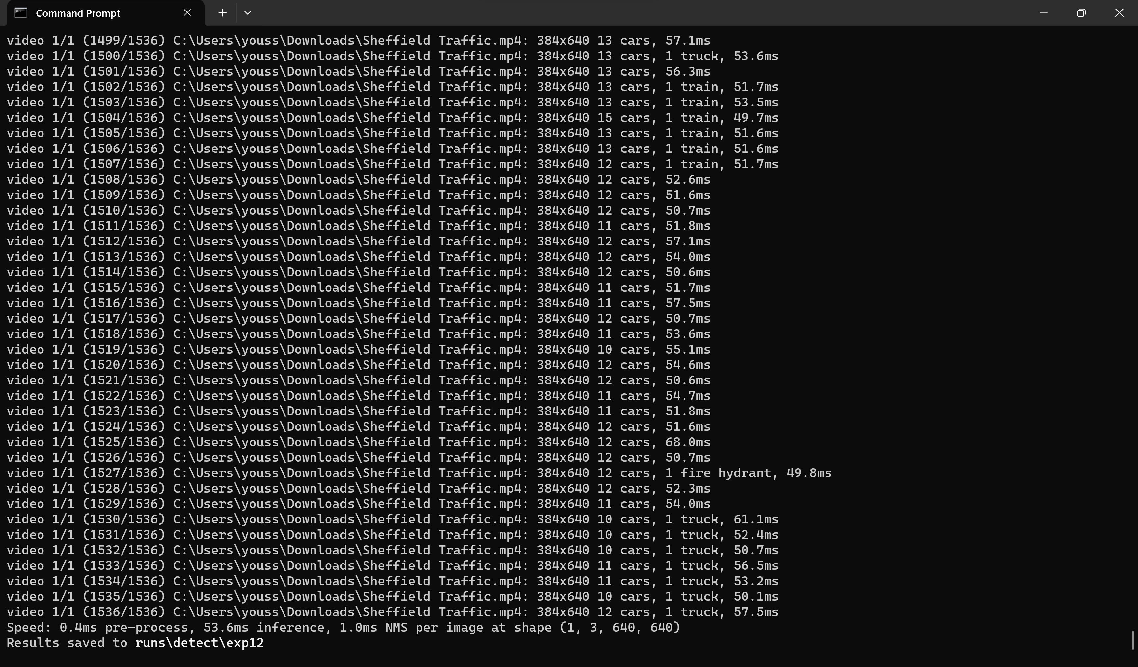

1. living-room-interior

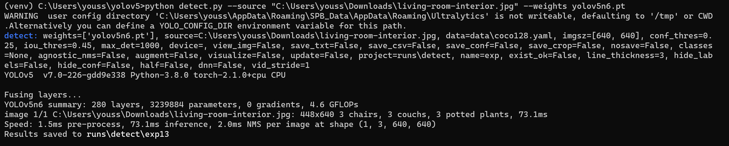

1. football-raw-clip

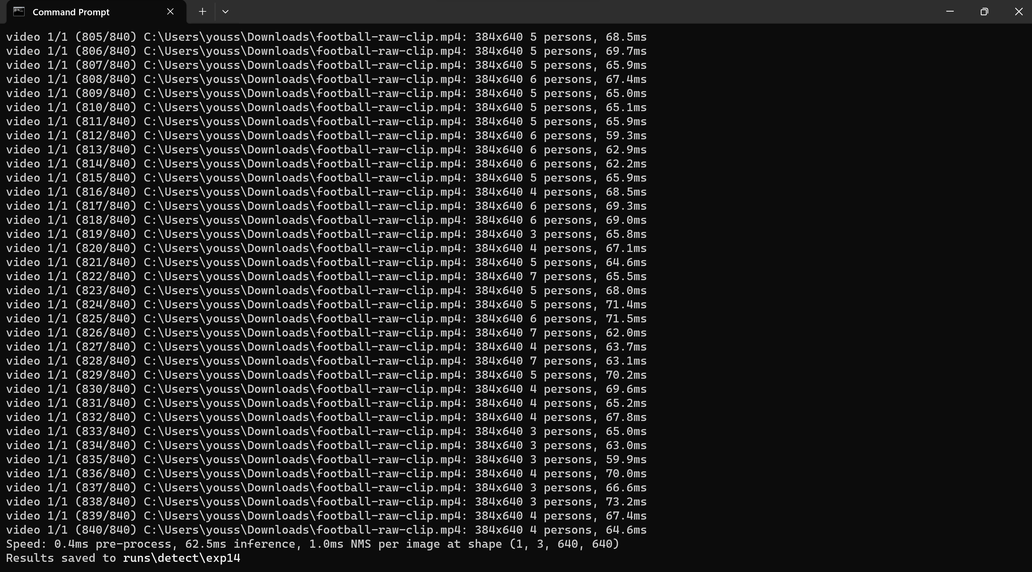

1. denver-open-streets

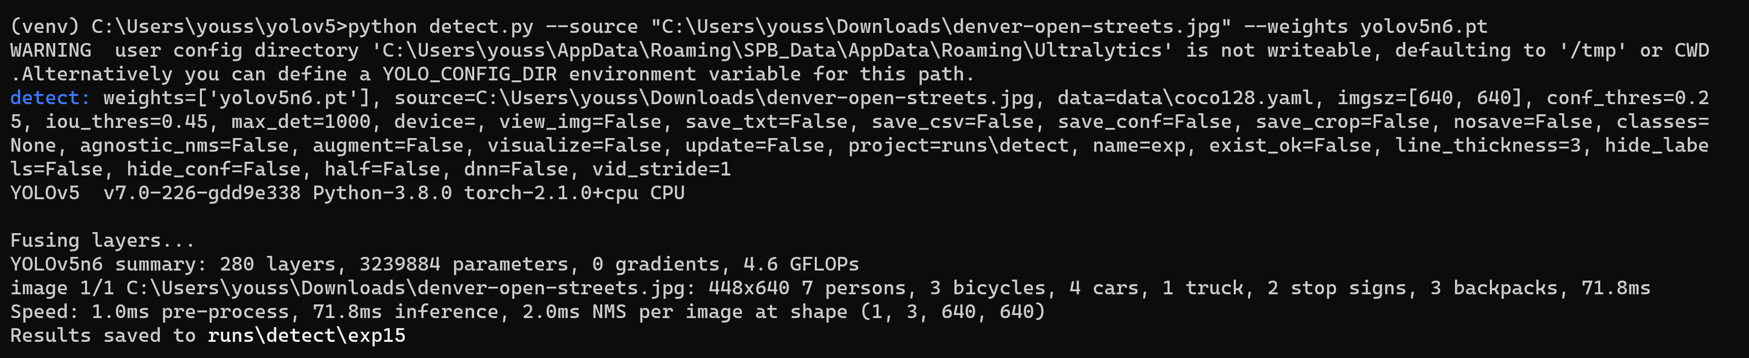

1. cats_and_dogs

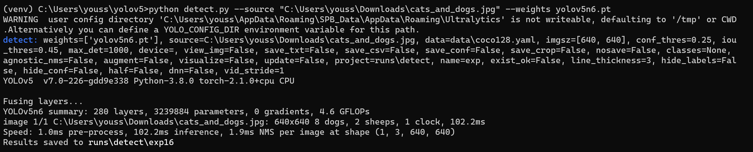

For Yolo v7

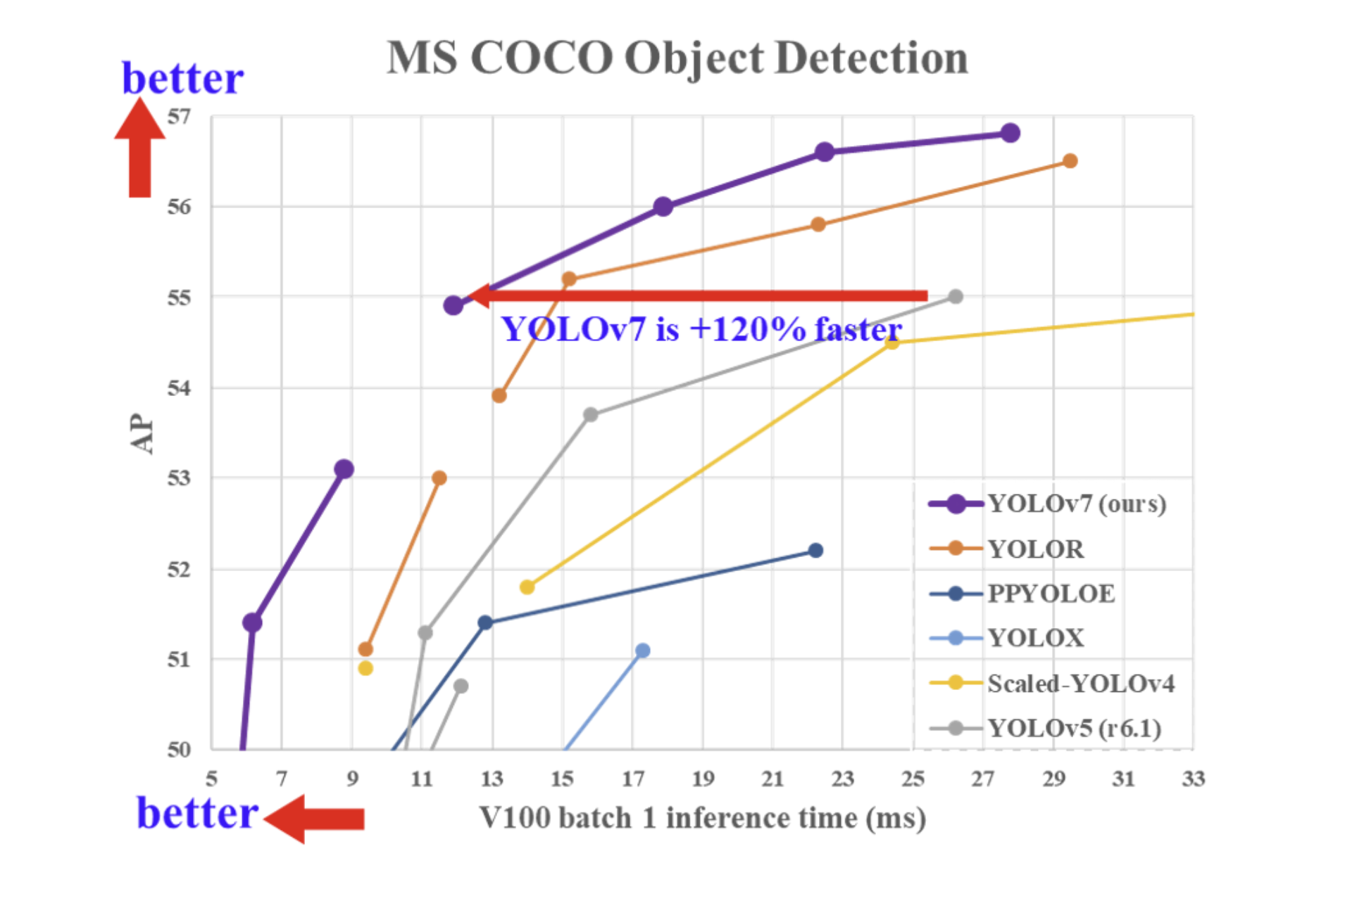

Using yolov7.pt

1. Sheffield Traffic

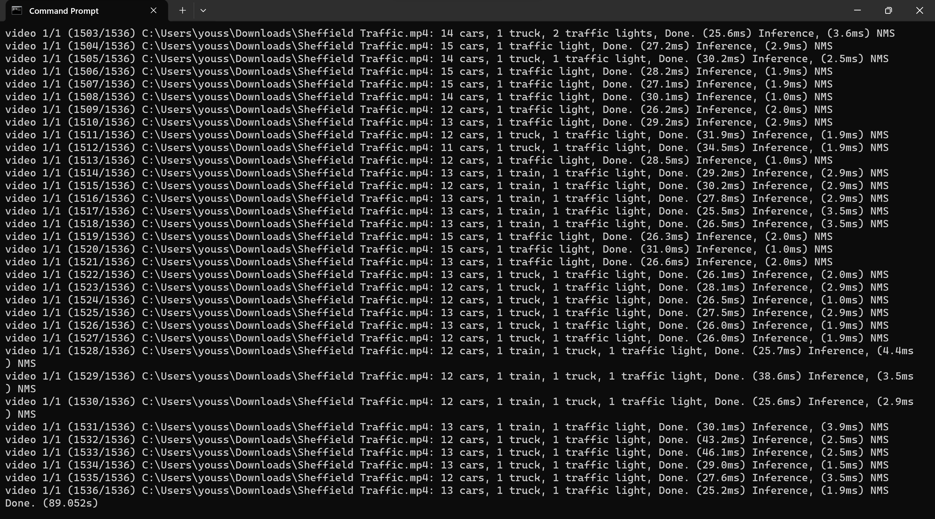

1. living-room-interior

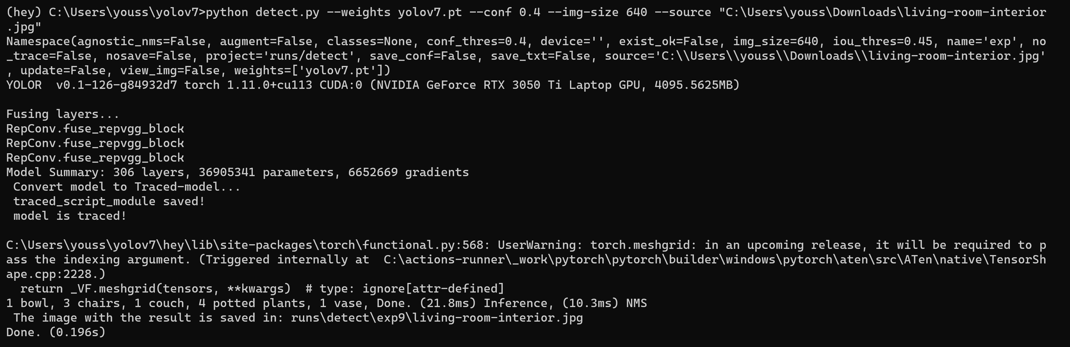

1. football-raw-clip

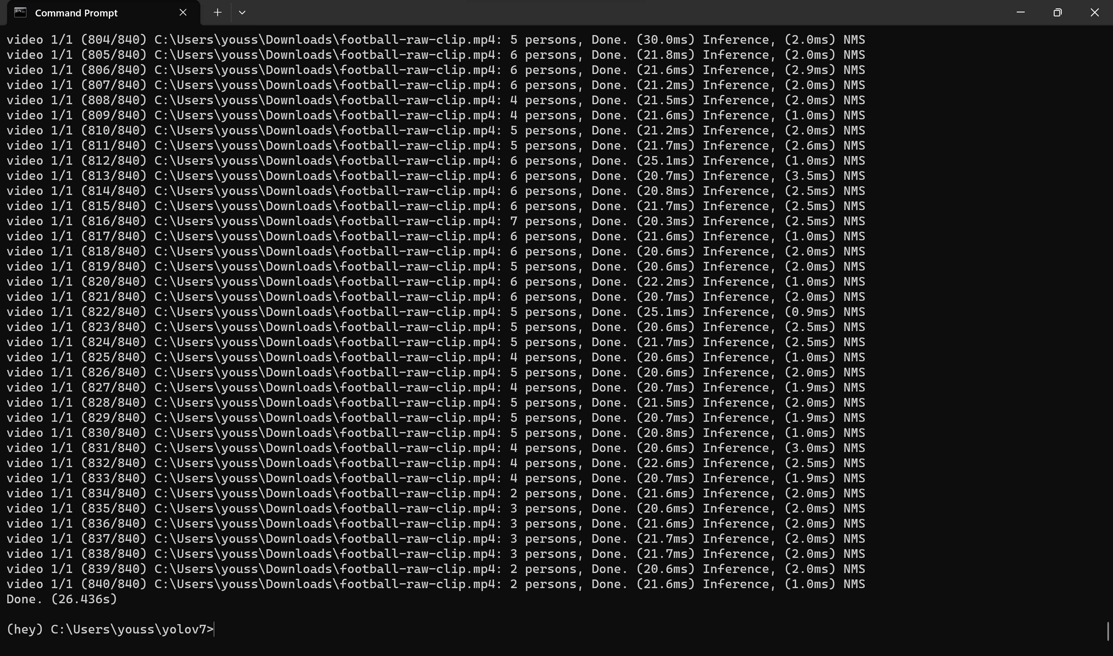

1. denver-open-streets

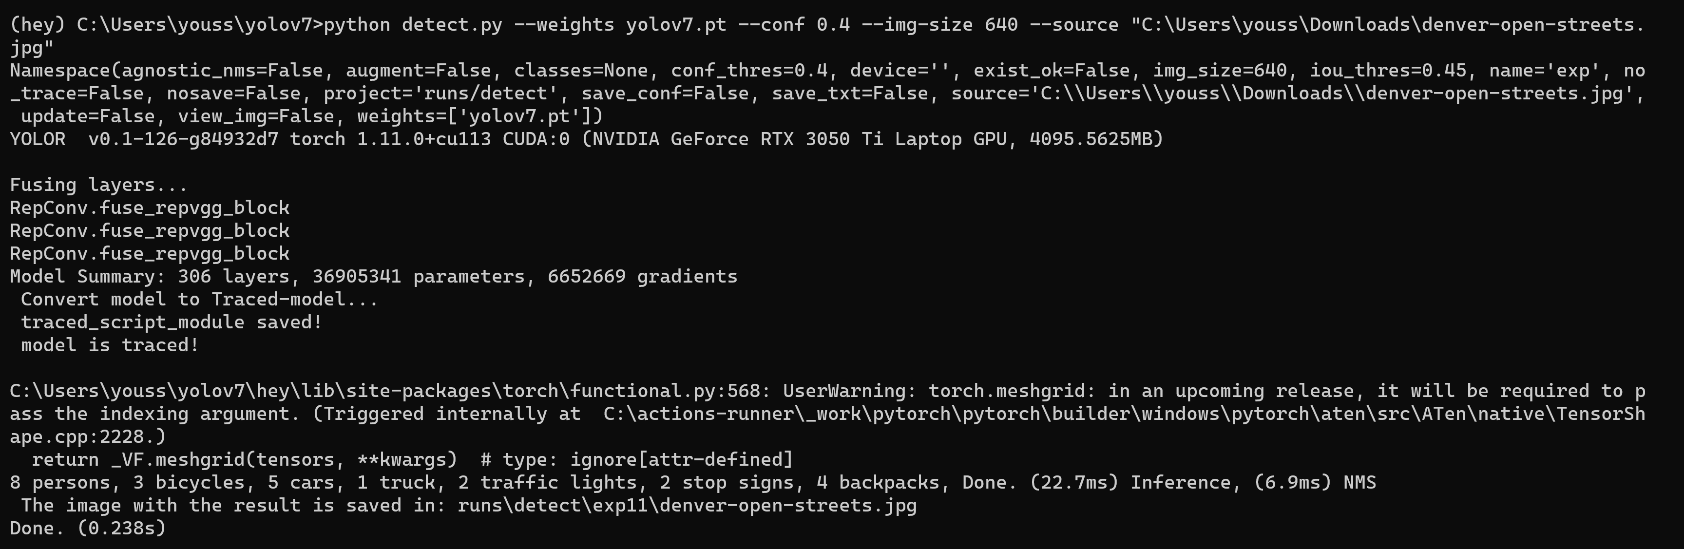

1. cats_and_dogs

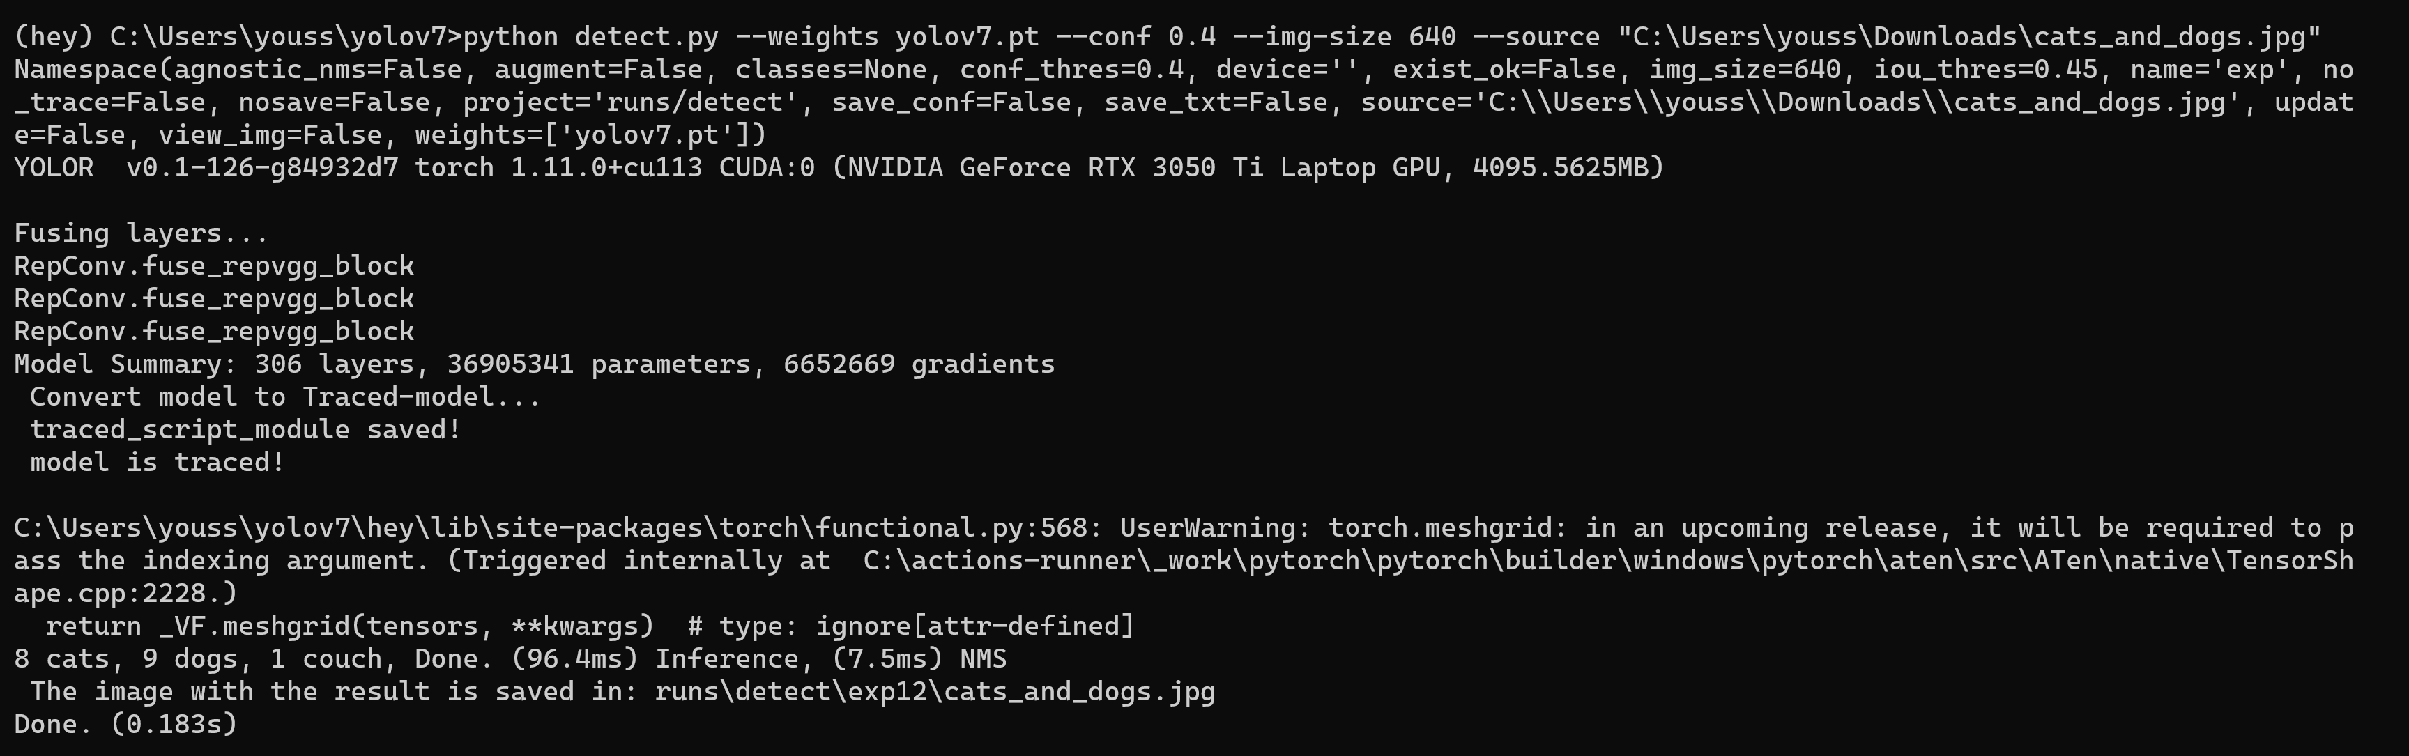

For Yolo v8

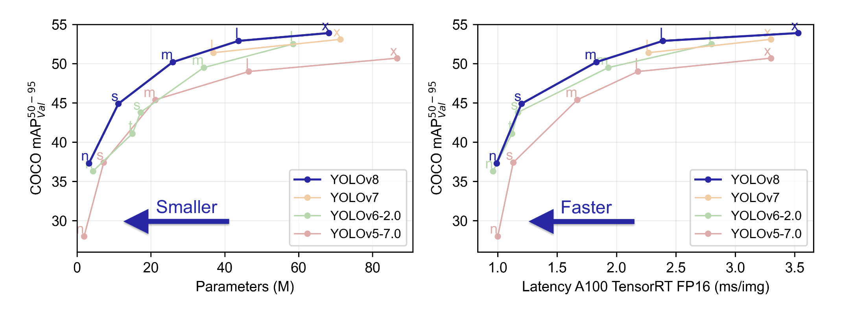

Using yolov8n.pt

1. Sheffield Traffic

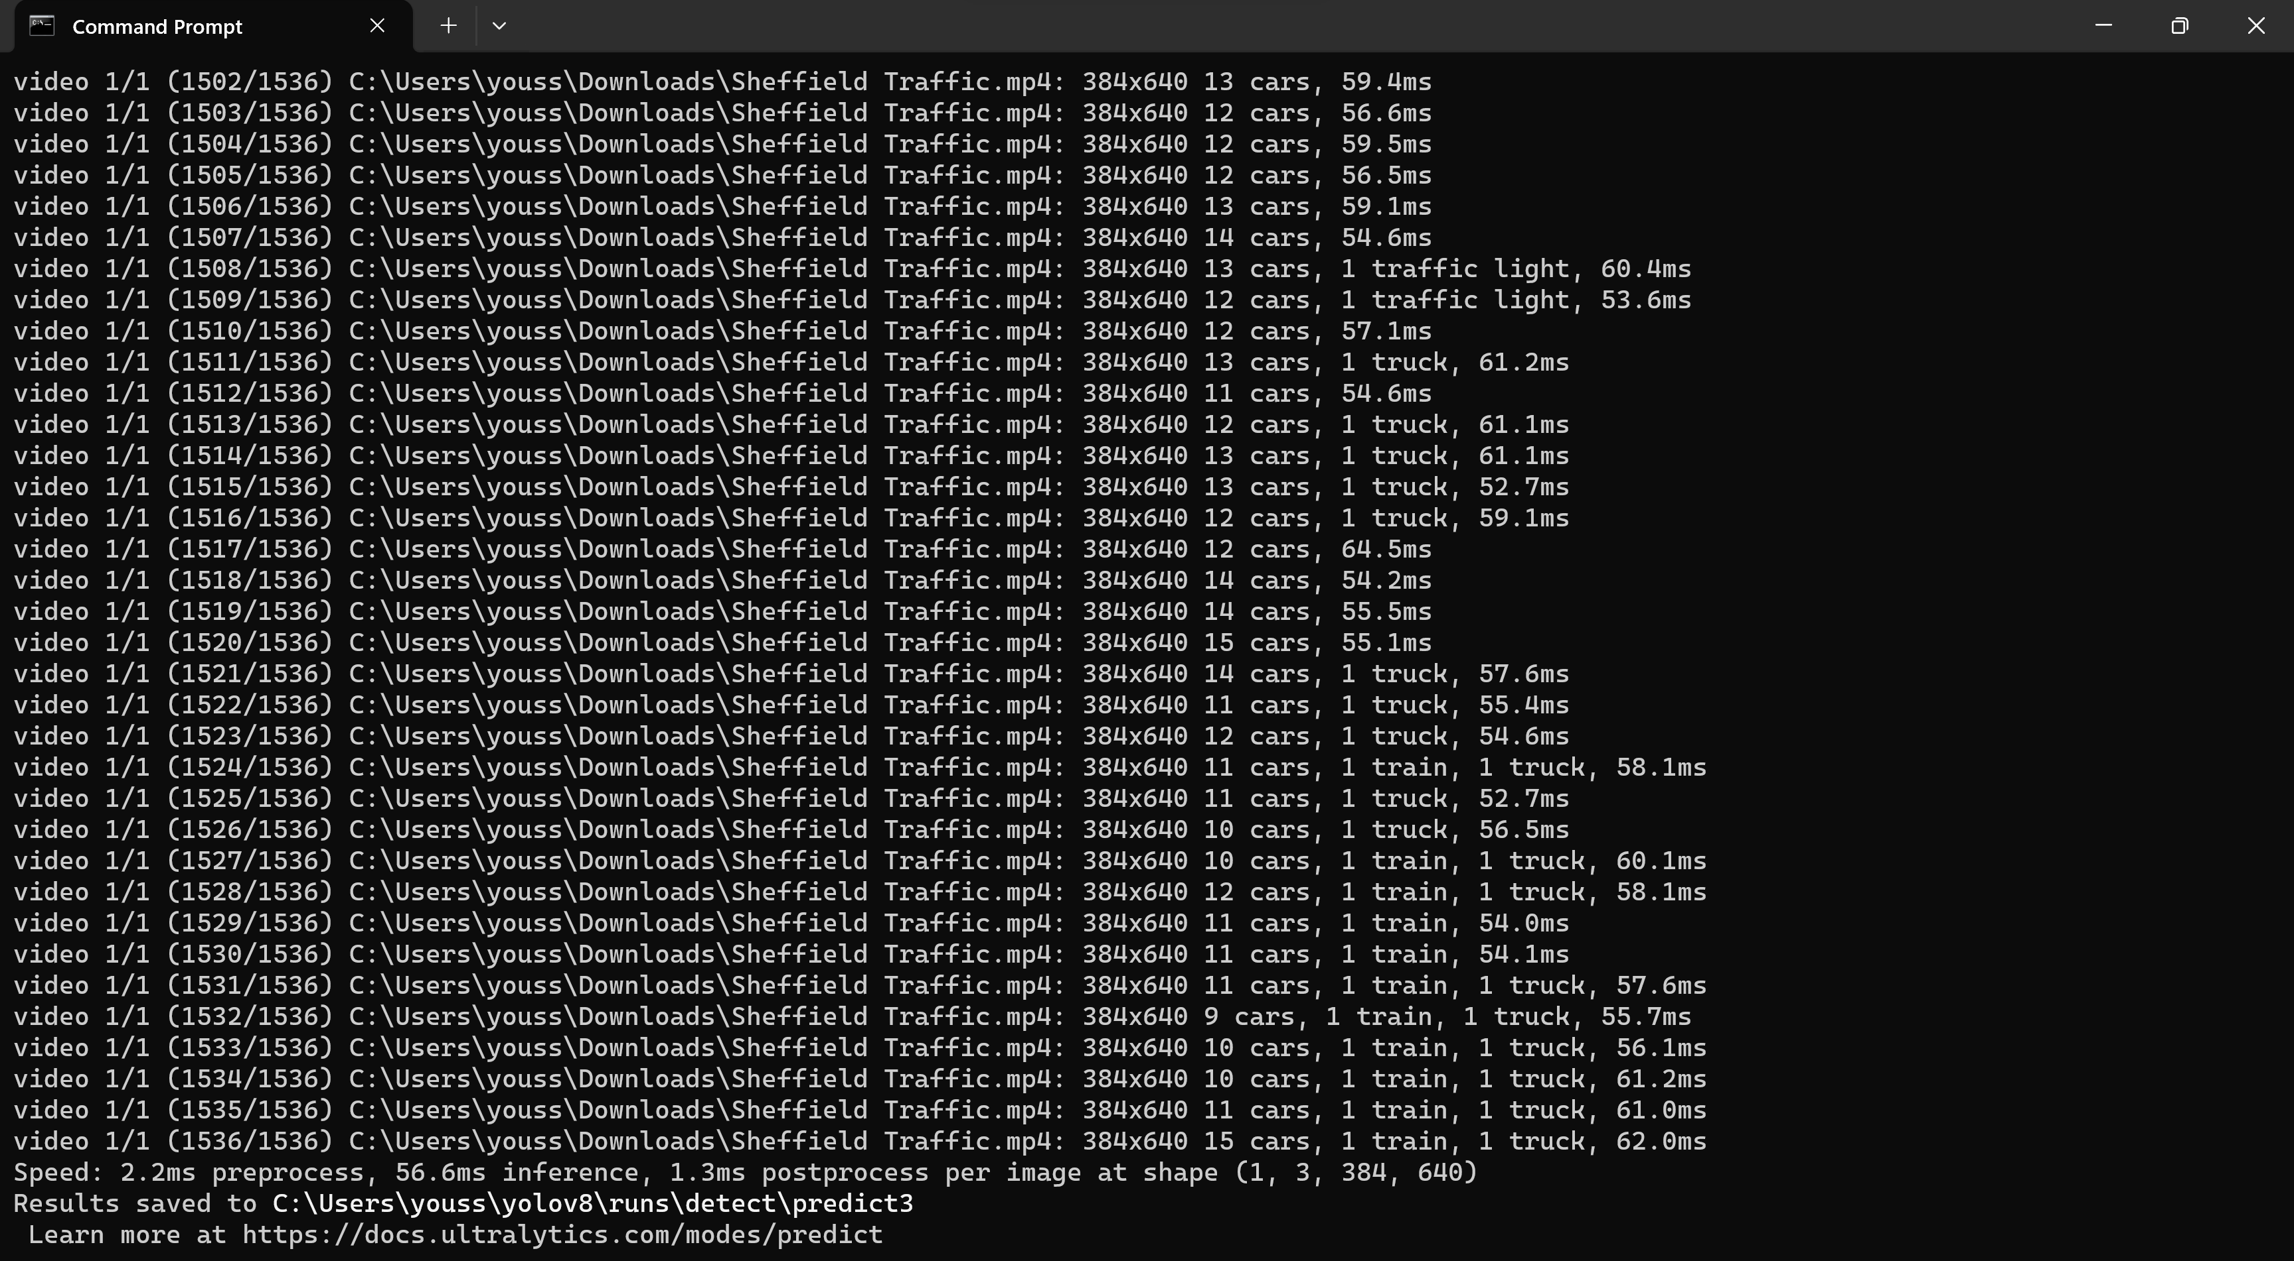

1. living-room-interior

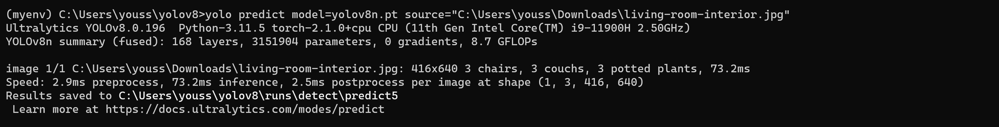

1. football-raw-clip

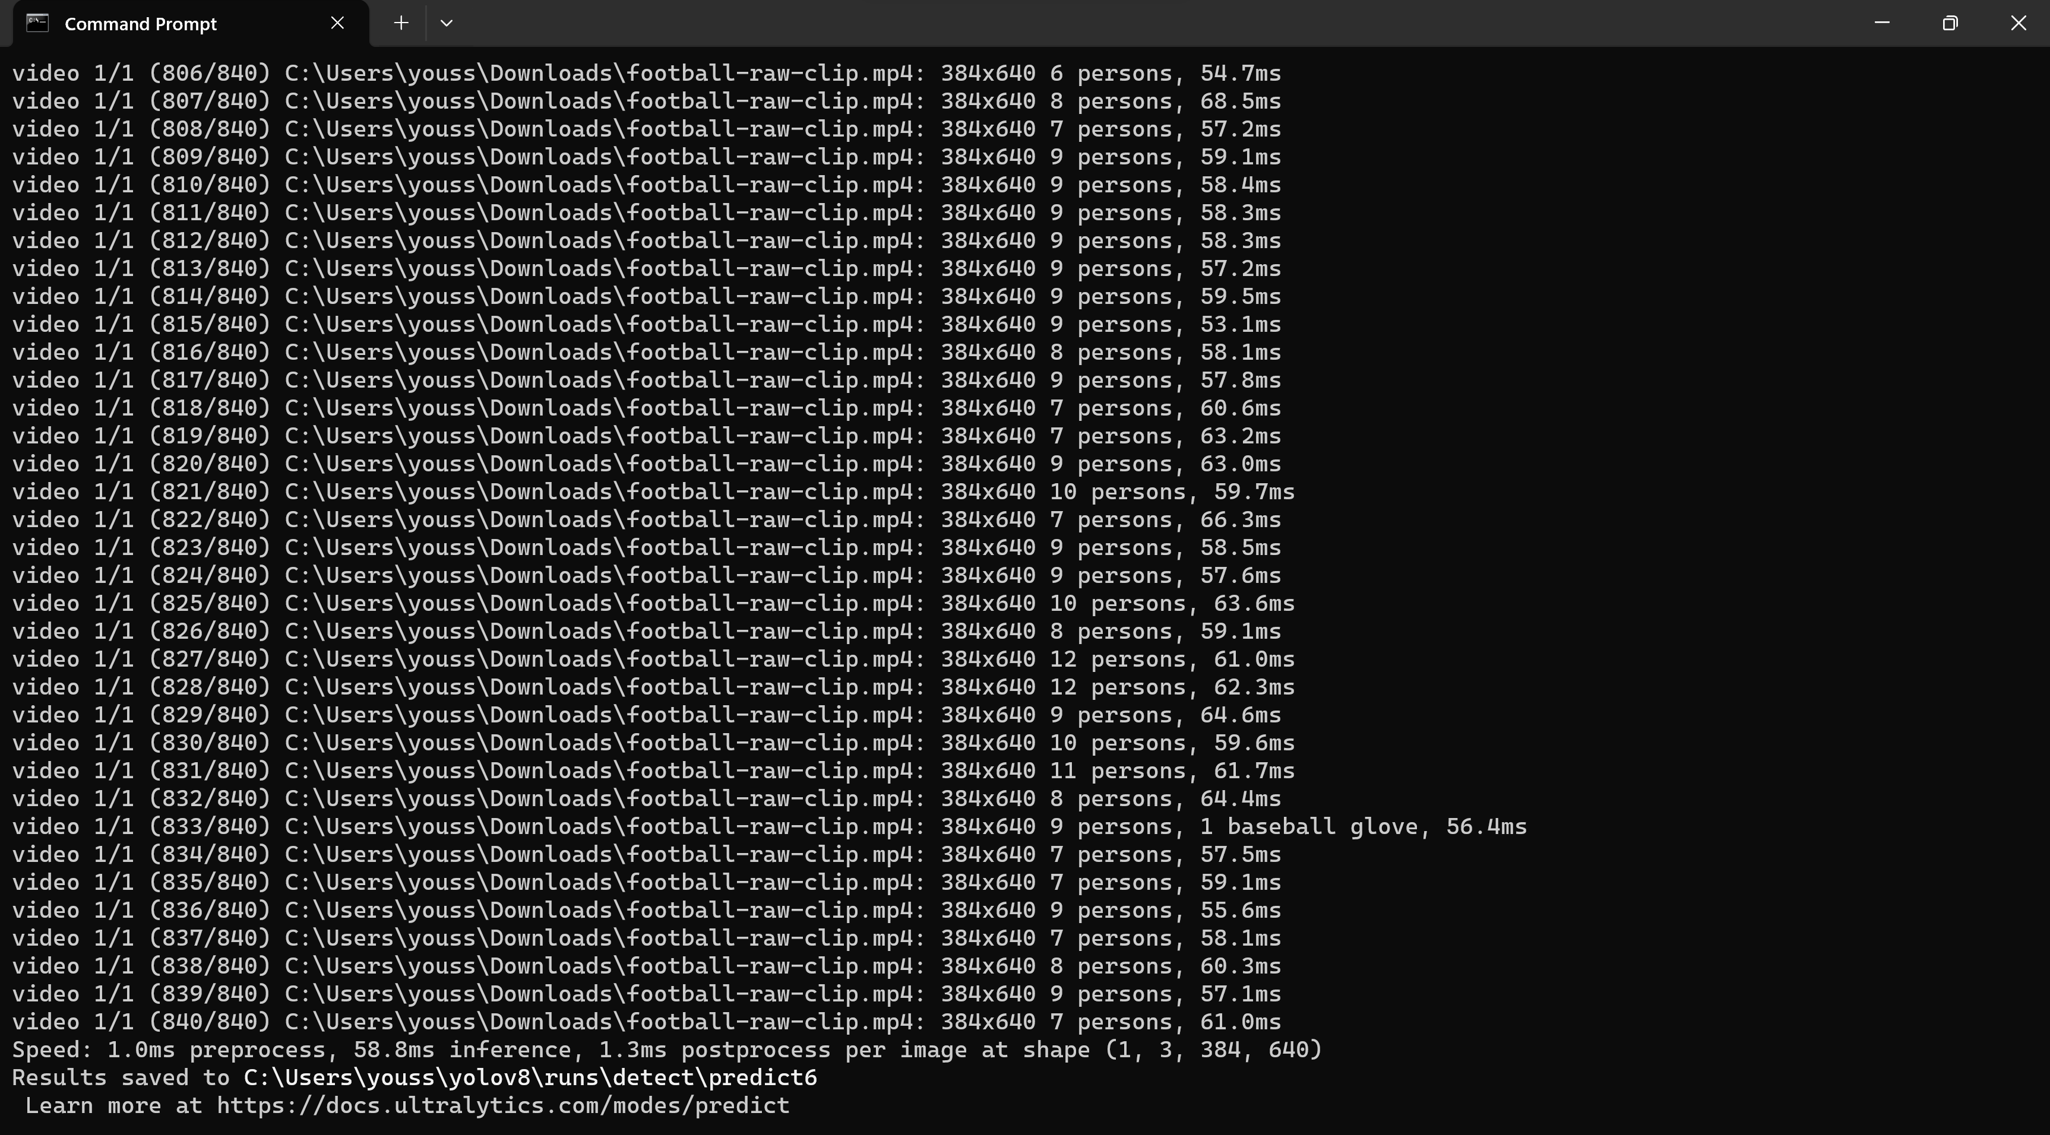

1. denver-open-streets

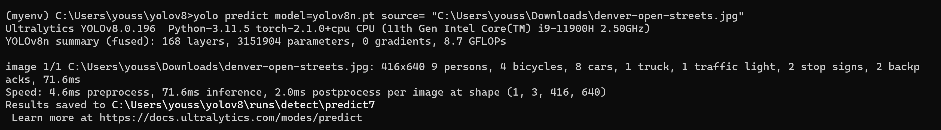

1. cats_and_dogs

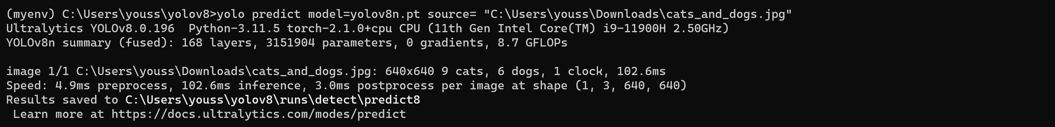

For Yolo v8

Using yolov8x.pt

1. Sheffield Traffic

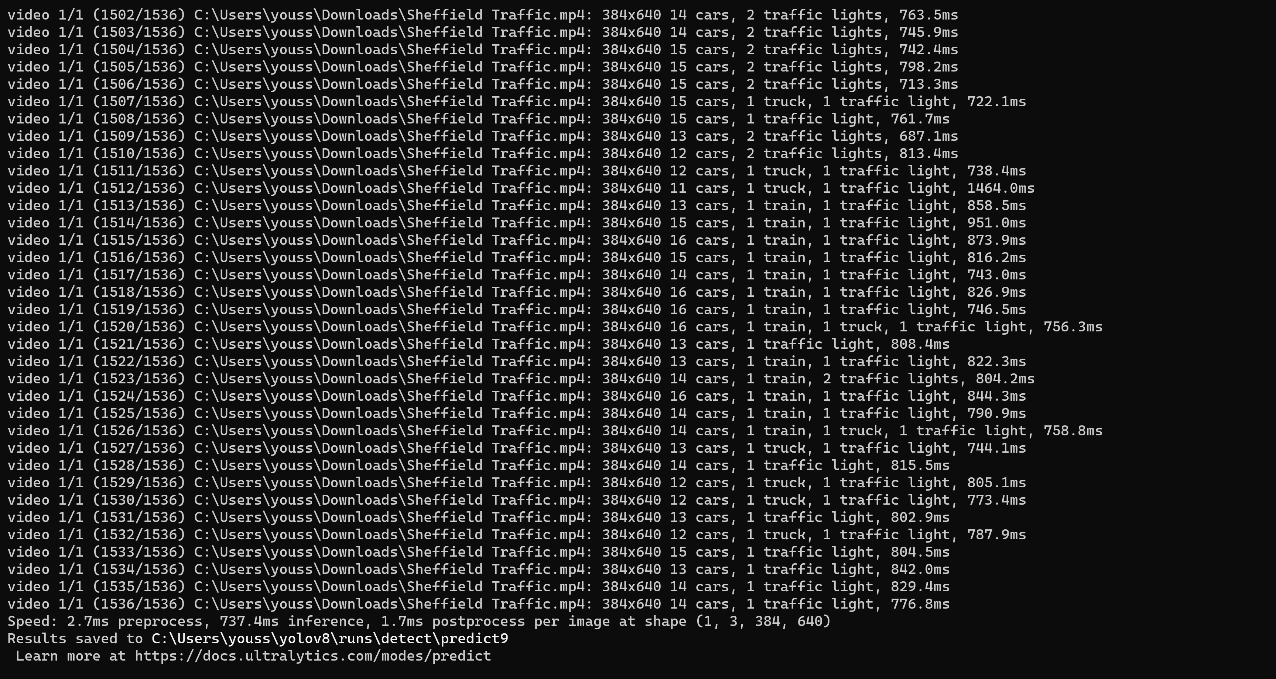

1. living-room-interior

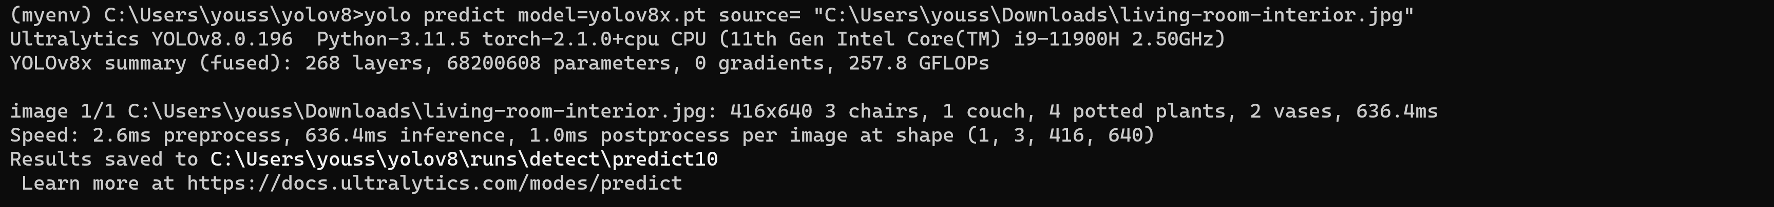

1. football-raw-clip

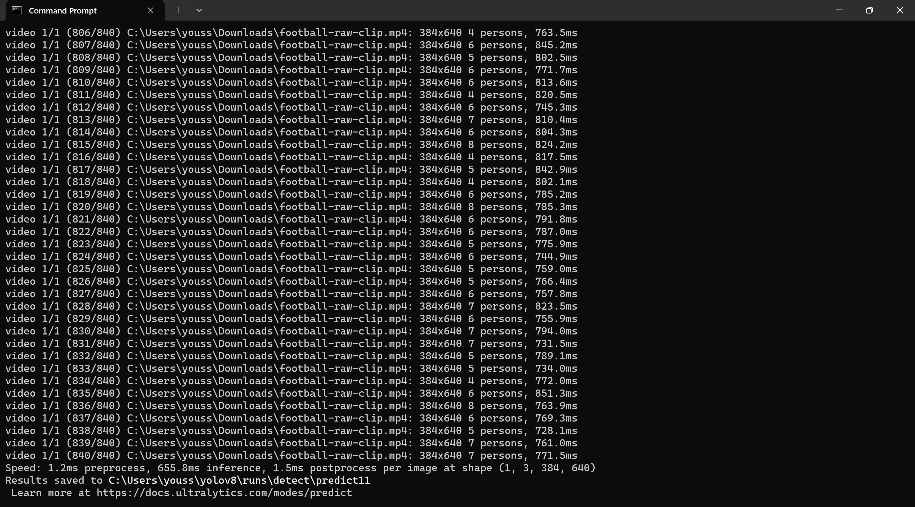

1. denver-open-streets

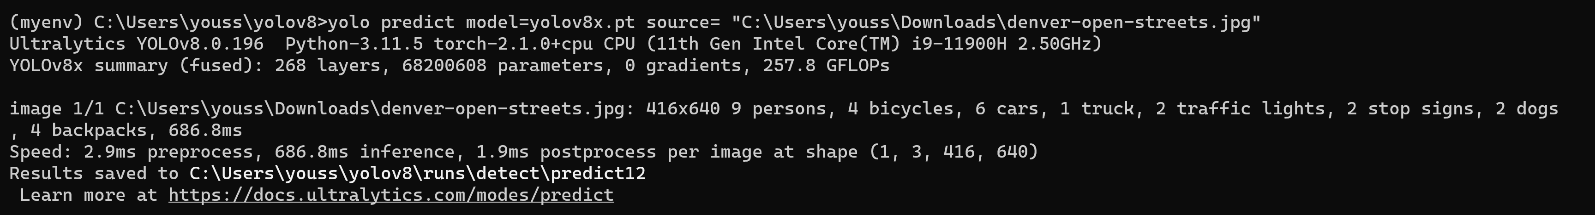

1. cats_and_dogs

